

930 Reedy Creek Road

Cary, NC 27513

**phone:** 919.460.3504

**fax:** 919.670-4278

##### Reedy Creek Magnet Middle School

September 24, 2021

Dear Parent/Guardian:

As a parent/guardian of a student in Reedy Creek Magnet Middle School, I am writingthis letter to let you know that Reedy Creek Magnet Middle School was designated as a Targeted Support & Improvement Additional Targeted Support (TSI-AT) School by the North Carolina State Board of Education in 2019. As stated in ESSA Section 1111(d)(2), North Carolina had to identify schools for targeted support and improvement. TSI-AT schools in North Carolina are those that have a subgroup that is under-performing. Per guidelines, RCMMS will remain in TSI-AT status for three years, regardless of annual progress, at which time it is eligible to exit. The intent of this opportunity is to improve educational outcomes for all students, close achievement gaps, increase equity, and improve the quality of instruction.

As a TSI-AT school, Reedy Creek Magnet Middle School has developed a comprehensive plan that specifically addresses how the school will improve student achievement. The plan includes how our district will support us and monitor the progress of our school.

Parent engagement is at the heart of our school improvement efforts. Here are some ways we can work together:

* Make sure that both you and your child are aware of academic expectations set for our students this school year.  A list of learning objectives in student-friendly language is available from your child’s teacher(s).
* Call your child’s grade level counselorif you have questions or concerns about your student or to set up an appointment to meet with a school staff member who will be working with your child.
* Make sure that your child is prepared and attends school each day.
* Monitor your child’s homework.
* Monitor the progress your child is making and attend meetings with your child’s teacher(s).
* Keep track of our website and social media sites [https://www.wcpss.net].
* Volunteer.
* Join the Reedy Creek Magnet Middle School’s PTA.

It sounds like a lot but preparing our students so that they can succeed is not easy and is a group effort. Here are some resources available to help:

* Graduation requirements: [www.ncpublicschools.org/gradrequirements/](http://www.ncpublicschools.org/gradrequirements/)
* K-12 standards in academic subjects: [www.ncpublicschools.org/curriculum/](http://www.ncpublicschools.org/curriculum/)
* State student achievement test results: [www.ncpublicschools.org/accountability/](http://www.ncpublicschools.org/accountability/)
* N.C.School Report Cards: <https://ncreportcards.ondemand.sas.com/src>

If you have questions about the content of this letter, please contact me at [hevans@wcpss.net](mailto:hevans@wcpss.net)or 919-460-3504.

In partnership,

H. Trent Evans

H. Trent Evans

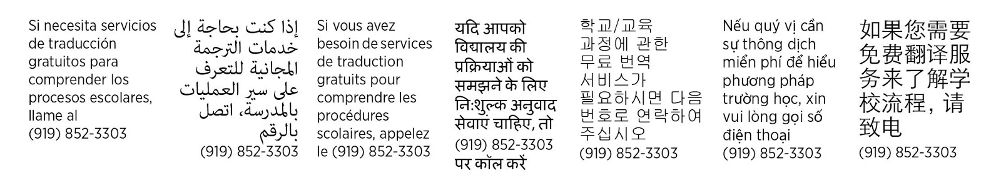

**Top of Form**